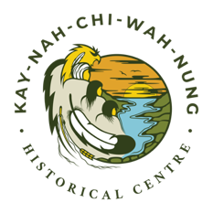
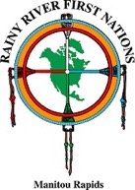
RAINY RIVER FIRST NATIONS
Invites applications for the position of

WINTER TOUR/TRAIL GUIDES
1 Full-Time & 1 Part-Time Position
KAY-NAH-CHI-WAH-NUNG HISTORICAL CENTRE
Reporting to the Manager of Administration of KNCWN, the winter tour guides will be responsible for taking groups on indoor tours of the Interpretive Centre as well as outdoor tours of the trails on skiis or showshoes. The positions will run between January-April 2019 with possible extensions depending on weather.

QUALIFICATIONS:
- Minimum Grade 12;
- Minimum of 1 years’ experience in dealing with the public;
- Develops and maintains effective relationships with staff and the public;
- Excellent verbal communication skills;
- Knowledge of Indigenous culture & Rainy River First Nations desired;
- Comfortable working outdoors;
- Comfortable with physical activity (some heavy lifting may be required);
- Comfrotable working with individuals of varying age groups
- CPR/First-Aid certification is an asset

TERMS AND CONDITIONS:
- Must be able to provide current Criminal Reference Check satisfactory to the First Nation;
- Must adhere to the Rainy River First Nations’ Drug Testing Policy;
- Must have the ability to work flexible work hours, which may include evenings and weekends;
- Must have valid driver’s license and access to a vehicle or ability to find alternate means of transportation

Please apply in writing by 4:00 PM on Monday, January 7, 2019. Applications must include a cover letter, current resume, three (3) employment related references (two of which must be from a current or recent supervisor) with permission to contact these references.
Please submit application to: Verna DeBungie - Human Resources Manager
Rainy River First Nations
P.O. Box 450
Emo ON P0W 1E0
Email: v.debungie@rrfns.com

For further information, please contact Verna Debungie at (807) 482-2479 ext. 249.

We thank all applicants but only those invited for an interview will be contacted.

